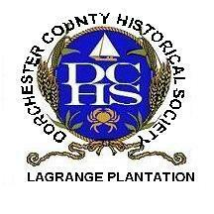
Dorchester County
Historical Society
2023 Membership Form

Your support helps us preserve and protect local history!

Today’s Date:________________________

Name____________________________________________________________________________

Mailing Address____________________________________________________________________

____________________________________________________________________________________

Phone Number_____________________________ Email___________________________________

_______Email my newsletter _______Contact me about volunteering
Membership Level:
_____Student $5 _____Family $60
_____Individual $35 _____Benefactor – NARM $100**

You May Now Join & Renew Your Membership Online!
www.dorchesterhistory.com
**Called the North American Reciprocal Museum, this association gains you access to over 1,000 museums and institutions across North America.
https://narmassociation.org/
Dorchester County Historical Society
1003 Greenway Drive Cambridge, Maryland 21613
410.228.7953 dchs@verizon.net
Staff Use
EXCEL _____
EMAIL _____
LET/CARD _____
ELECT. N/L _____
VOLUNTEER _____

