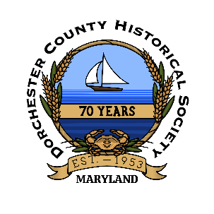
Dorchester County
Historical Society
2024 Member & Sponsor Form

1003 Greenway Drive Cambridge, Maryland 21613
410.228.7953 dchs@verizon.net

Today’s Date:________________________

Name____________________________________________________________________________

Mailing Address____________________________________________________________________

____________________________________________________________________________________

Phone Number_____________________________ Email___________________________________

_______Email my newsletter _______Contact me about volunteering

Membership Level: Sponsor Level:
_____Student $5 ____Corporate $150
_____Individual $35 ____Non-Profit $50
_____Family $60 ____Government $50
_____Benefactor – NARM $100**

You May Now Join & Renew Your Single or Family Membership Online!
www.dorchesterhistory.com
**Called the North American Reciprocal Museum, this association gains you access to over 1,000 museums and institutions across North America.
https://narmassociation.org/
Staff Use
EXCEL _____
EMAIL _____
LET/CARD _____
ELECT. N/L _____
VOLUNTEER _____
Ask us more about our sponsorship levels!

